A UNIVERSITY database for maintaining information concerning students, courses, and grades in a university environment is given below. The STUDENT file stores data on each student, the COURSE file stores data on each course, the SECTION file stores data on each section of a course, the GRADE_REPORT file stores the grades that students receive in the various sections they have completed, and the PREREQUISITE file stores the prerequisites of each course.

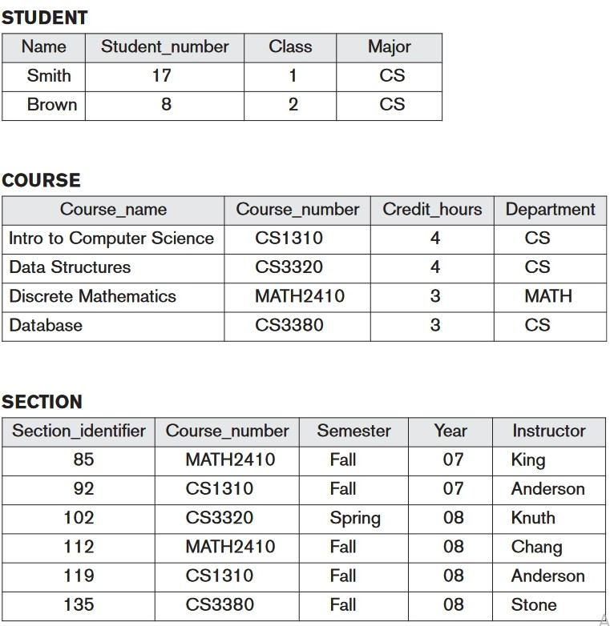

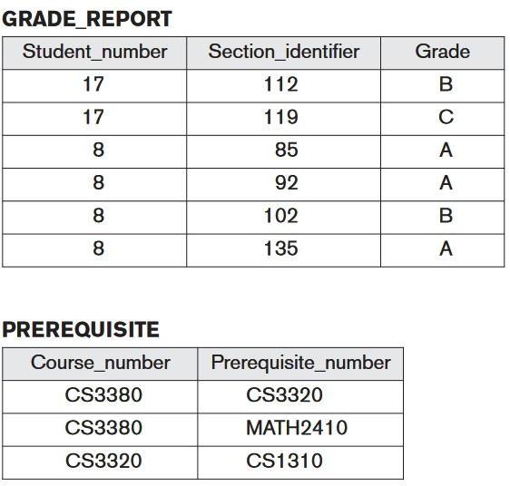

CREATE TABLE student(

s_no int primary key, s_name varchar(20) not null,

s_class int,

s_major varchar(10)

);

CREATE TABLE course(

c_no varchar(10) primary key, c_name varchar(50),

c_credit int,

c_dept varchar(20)

);

CREATE TABLE section(

s_identity int primary key,

s_cno varchar(20),

s_sem varchar(10), s_year varchar(5), s_instructor varchar(20)

);

CREATE TABLE grade_report( g_sec_identiy int primary key, g_stud_no int,

g_grade varchar(10)

);

CREATE TABLE prerequisite(

p_pre_no varchar(20) primary key, p_course_no varchar(20)

);

INSERT INTO student VALUES(17,'smith',1,'cs'); INSERT INTO student VALUES(8,'brown',2,'cs');

INSERT INTO course VALUES('CS1310','Intro to computer science',4,'cs'); INSERT INTO course VALUES('CS3320','Date structures',4,'cs');

INSERT INTO course VALUES('MATH2410','Discrete Mathematics',3,'cs'); INSERT INTO course VALUES('CS3380','Database',3,'cs');

INSERT INTO section VALUES(85,'MATH2410','fall','07','king');

INSERT INTO section VALUES(92,'CS1310','fall','07','anderson');

INSERT INTO section VALUES(102,'CS3320','spring','08','knuth'); INSERT INTO section VALUES(112,'MATH2410','fall','08','chang');

INSERT INTO section VALUES(119,'CS1310','fall','08','anderson');

INSERT INTO section VALUES(135,'CS3380','fall','08','stone');

INSERT INTO grade_report VALUES(112,17,'B'); INSERT INTO grade_report VALUES(119,17,'C');

INSERT INTO grade_report VALUES(85,8,'A'); INSERT INTO grade_report VALUES(92,8,'A'); INSERT INTO grade_report VALUES(102,8,'B'); INSERT INTO grade_report VALUES(135,8,'A');

INSERT INTO prerequisite VALUES('CS3320','CS3380'); INSERT INTO prerequisite VALUES('MATH2410','CS3380'); INSERT INTO prerequisite VALUES('CS1310','CS3320');

1.List the prerequisites of the ‘Database’ course.

SELECT prerequisite.p_pre_no FROM prerequisite INNER JOIN course ON prerequisite.p_course_no=course.c_no WHERE course.c_name='Database';

2.Retrieve the names of all senior students majoring in‘CS’(computerscience). select s_name from student where s_major='CS' and s_class=4;

3.Retrieve the names of all courses taught by Professor King in 2007 and 2008.

SELECT course.c_name FROM section INNER JOIN course ON section.s_cno=course.c_no WHERE section.s_instructor='king' AND section.s_year IN('07','08');

4. Delete therecord forthestudentwhose nameis ‘Smith’and whose student number is 17.

DELETE FROM student WHERE s_name='smith' AND s_no=17;

5.List the names of students who took the section of the ‘Database’ course oﬀered in fall 2008 and their grades in that section.

SELECT student.s_name,grade_report.g_grade,course.c_name FROM student INNER JOIN grade_report ON student.s_no=grade_report.g_stud_no INNER JOIN section ON grade_report.g_sec_identiy=section.s_identity INNER JOIN course ON section.s_cno=course.c_no WHERE course.c_name='Database' AND section.s_sem='fall' AND section.s_year='08';